**Lab No: 5 Developing Web Application using Django - Part I**

**Name: Ketan Goud**

**Reg No: 220905260**

**Section: D D2**

**Roll No: 39**

**Develop a simple web page to reproduce the given Captcha. Upon match, suitable message must be displayed. If there is a mismatch for more than 3 times, Textbox must be disabled.**

Settings.py

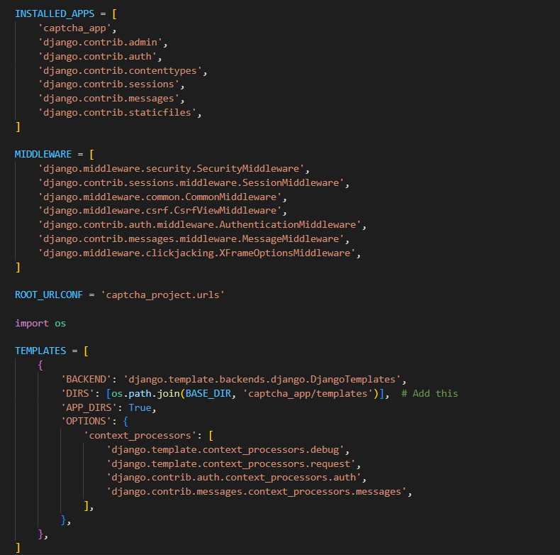

Captcha_app\urls.py

Captcha_project\urls.py

Captcha_app\models.py

Captcha_app\views.py

HTML file

